Highest Rated Movie
Pig Latin Script to display the name of the movie which has the highest rating:

-- Load the ratings data
ratings = LOAD '/user/maria_dev/ml-100k/u.data' AS (userID:int, movieID:int, rating:int, ratingTime:int);
-- Load the metadata about movies
metadata = LOAD '/user/maria_dev/ml-100k/u.item' USING PigStorage('|')
AS (movieID:int, movieTitle:chararray, releaseDate:chararray, videoRelease:chararray, imdbLink:chararray);
-- Transform the releaseDate to Unix time and generate a new relation
nameLookup = FOREACH metadata GENERATE movieID, movieTitle,
ToUnixTime(ToDate(releaseDate, 'dd-MMM-yyyy')) AS releaseTime;
-- Group the ratings by movieID
ratingsByMovie = GROUP ratings BY movieID;
-- Calculate the average rating for each movie
avgRatings = FOREACH ratingsByMovie GENERATE group AS movieID, AVG(ratings.rating) AS avgRating;
-- Filter the movies with an average rating greater than 4.0
fiveStarMovies = FILTER avgRatings BY avgRating > 4.0;
-- Join the filtered movies with their metadata
fiveStarsWithData = JOIN fiveStarMovies BY movieID, nameLookup BY movieID;
-- Order the resulting movies by their release time
oldestFiveStarMovies = ORDER fiveStarsWithData BY nameLookup::releaseTime;
-- Output the final result to the console
DUMP oldestFiveStarMovies;

Here is a break down the Apache Pig script shown in the image step by step:
Script Breakdown
1. Load Data
pig
Copy code
ratings = LOAD '/user/maria_dev/ml-100k/u.data' AS (userID:int, movieID:int, rating:int, ratingTime:int);
- Purpose: Load the ratings data from the specified path.
- Schema: The data is loaded with the schema (userID:int, movieID:int, rating:int, ratingTime:int).
pig
Copy code
metadata = LOAD '/user/maria_dev/ml-100k/u.item' USING PigStorage('|')
AS (movieID:int, movieTitle:chararray, releaseDate:chararray, videoRelease:chararray, imdbLink:chararray);
- Purpose: Load the metadata about movies from the specified path.
- Schema: The data is loaded with the schema (movieID:int, movieTitle:chararray, releaseDate:chararray, videoRelease:chararray, imdbLink:chararray).
- PigStorage('|'): Specifies that the data fields are separated by a pipe (|) character.
2. Transform Metadata
pig
Copy code
nameLookup = FOREACH metadata GENERATE movieID, movieTitle,
ToUnixTime(ToDate(releaseDate, 'dd-MMM-yyyy')) AS releaseTime;
- Purpose: Transform the releaseDate from string format to Unix time and generate a new relation with movieID, movieTitle, and releaseTime.
3. Group Ratings by Movie
pig
Copy code
ratingsByMovie = GROUP ratings BY movieID;
- Purpose: Group the ratings data by movieID.
4. Calculate Average Ratings
pig
Copy code
avgRatings = FOREACH ratingsByMovie GENERATE group AS movieID, AVG(ratings.rating) AS avgRating;
- Purpose: Calculate the average rating for each movie.
- Schema: The new relation contains movieID and avgRating.
5. Filter Movies with Average Rating Greater than 4.0
pig
Copy code
fiveStarMovies = FILTER avgRatings BY avgRating > 4.0;
- Purpose: Filter the movies to only include those with an average rating greater than 4.0.
6. Join with Metadata
pig
Copy code
fiveStarsWithData = JOIN fiveStarMovies BY movieID, nameLookup BY movieID;
- Purpose: Join the filtered movies with their metadata on movieID.
7. Order by Release Time
pig
Copy code
oldestFiveStarMovies = ORDER fiveStarsWithData BY nameLookup::releaseTime;
- Purpose: Order the resulting movies by their releaseTime in ascending order.
8. Output the Result
pig
Copy code
DUMP oldestFiveStarMovies;
- Purpose: Output the final result to the console.
Summary
This Pig script performs the following steps:
- Loads the ratings data and metadata.
- Transforms the releaseDate in the metadata to Unix time.
- Groups the ratings by movieID and calculates the average rating for each movie.
- Filters the movies to only include those with an average rating greater than 4.0.
- Joins this filtered set with the movie metadata.
- Orders the final set of movies by their release time.
- Outputs the final list of movies.
The result is a list of movies with an average rating greater than 4.0, ordered by their release time, including their metadata such as movie title and release time.

Note: If we select Execute on Tez, it will execute faster, tez computes the asyclic dag graph and figure out all the steps.

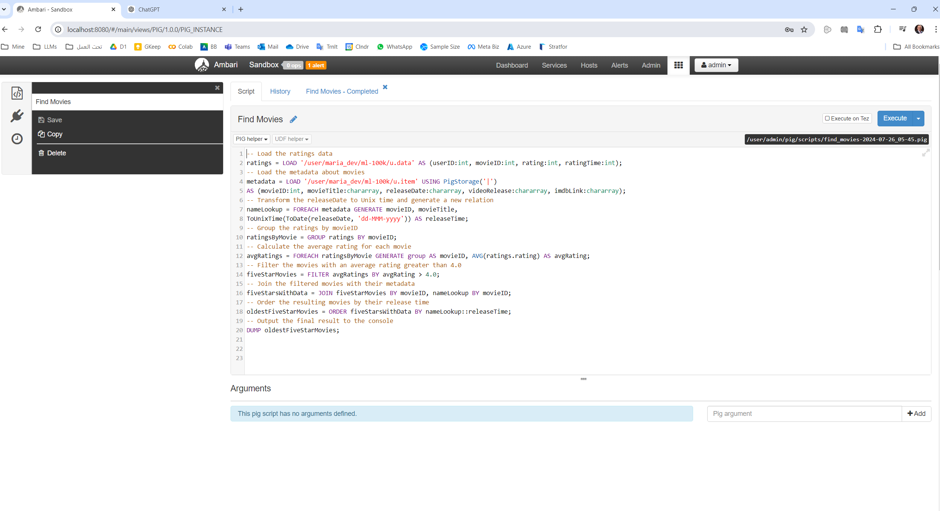

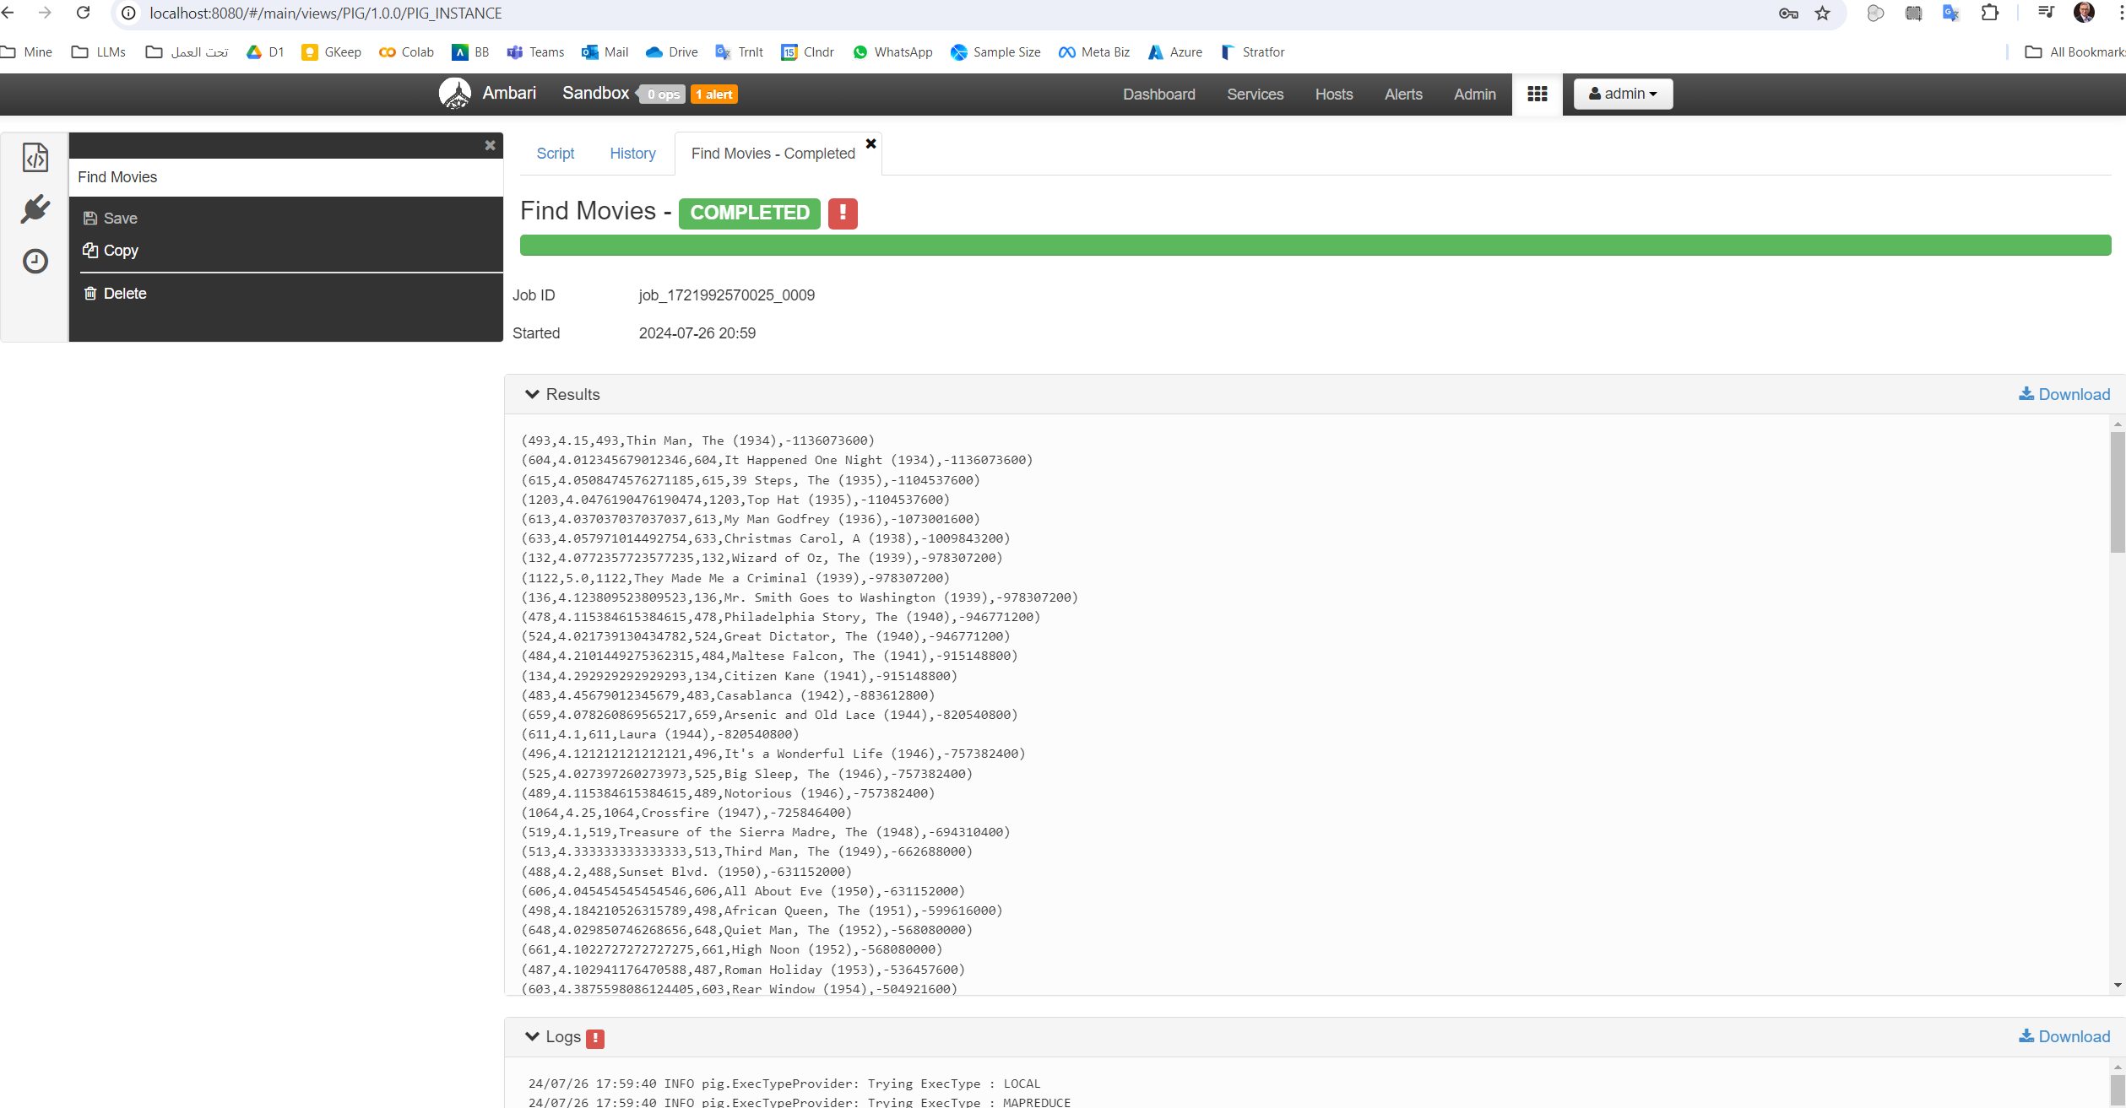

Hive was Faster than Pig, Why?
Hive can be significantly faster than Pig in executing certain jobs on the same data. There are several reasons why this might be the case:
Execution Engines
- Execution Engines:
  - Hive: Hive can use more advanced execution engines like Tez and Spark, which are optimized for performance. These engines provide better optimization, in-memory processing, and reduced overhead compared to MapReduce.
  - Pig: While Pig can also use Tez, it traditionally relies on MapReduce, which can be slower due to its disk-based intermediate data processing.
Optimization Techniques
- Query Optimization:
  - Hive: Hive includes a cost-based optimizer (CBO) and various query optimization techniques that can significantly improve performance by reordering operations, eliminating redundant tasks, and combining multiple stages.
  - Pig: Pig has optimization features, but they are not as advanced or effective as Hive’s cost-based optimizer.
In-Memory Processing
- In-Memory Processing:
  - Hive on Spark or Tez: These engines perform many operations in memory, which speeds up data processing by reducing the need to write intermediate data to disk.
  - Pig: Even when using Tez, Pig’s optimization and in-memory processing capabilities are generally not as advanced as Hive’s.
Data Caching
- Data Caching:
  - Hive on Spark: Spark can cache intermediate data in memory across operations, which can drastically improve performance for iterative algorithms and repeated queries.
  - Pig: Does not have a direct equivalent to Spark’s caching mechanisms.
Language and Optimization
- Language and Optimization:
  - HiveQL: HiveQL is a declarative language, which allows the Hive optimizer to understand the full context of the query and apply global optimizations more effectively.
  - Pig Latin: Pig Latin is a procedural language, which can make it harder to optimize globally since the execution plan is more rigidly defined by the script.
Example Comparison
Hive Query:
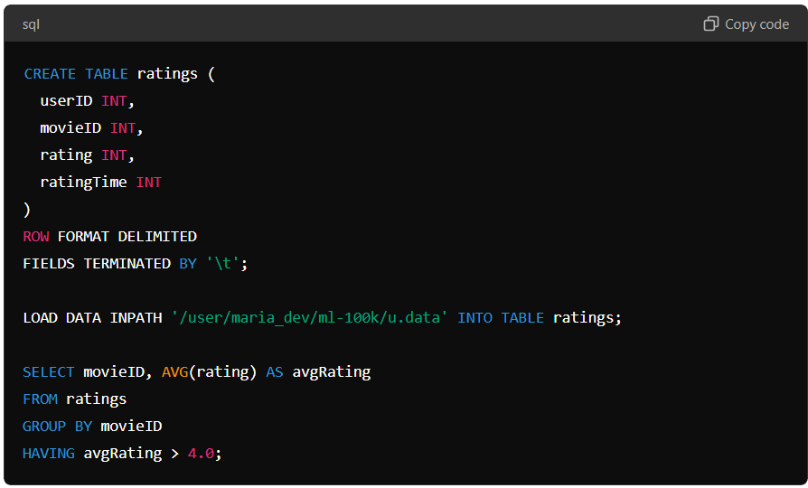
CREATE TABLE ratings (
userID INT,
movieID INT,
rating INT,
ratingTime INT
)
ROW FORMAT DELIMITED
FIELDS TERMINATED BY '\t';

LOAD DATA INPATH '/user/maria_dev/ml-100k/u.data' INTO TABLE ratings;

SELECT movieID, AVG(rating) AS avgRating
FROM ratings
GROUP BY movieID
HAVING avgRating > 4.0;
Pig Script:
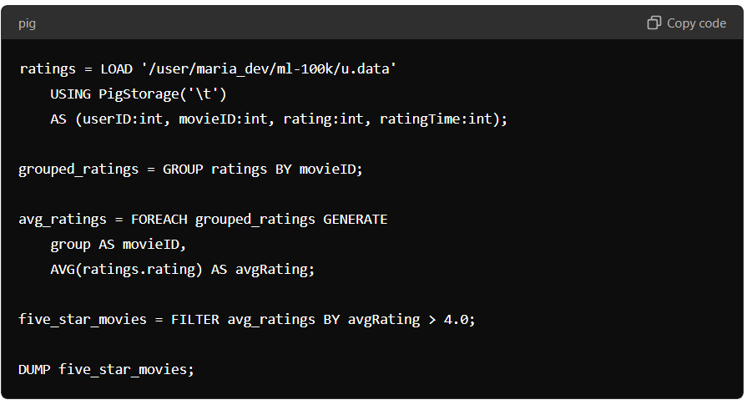
ratings = LOAD '/user/maria_dev/ml-100k/u.data'
USING PigStorage('\t')
AS (userID:int, movieID:int, rating:int, ratingTime:int);

grouped_ratings = GROUP ratings BY movieID;

avg_ratings = FOREACH grouped_ratings GENERATE
group AS movieID,
AVG(ratings.rating) AS avgRating;

five_star_movies = FILTER avg_ratings BY avgRating > 4.0;

DUMP five_star_movies;
Performance Factors
- Tez and Spark Optimizations: Hive on Tez or Spark can apply a variety of optimizations like task pipelining, DAG optimization, and efficient resource management, which are less effective or absent in Pig.
- In-Memory Computation: Spark's in-memory computation capabilities, when used with Hive, can significantly reduce the I/O overhead associated with traditional MapReduce operations.
- Cost-Based Optimizer: Hive's cost-based optimizer can make more informed decisions about query execution plans, leading to better performance.
Conclusion
While both Hive and Pig are designed to simplify data processing on Hadoop, Hive often outperforms Pig due to its use of more advanced execution engines, better optimization techniques, and in-memory processing capabilities. For many data processing tasks, especially those involving complex queries and aggregations, Hive provides a more efficient and faster execution compared to Pig.
If performance is a critical concern, using Hive with Tez or Spark as the execution engine is generally recommended over Pig, especially for complex and large-scale data processing tasks.

